**Home Task 6**

**Fundamentals of Programming**

Instructor: Sir Affan

Name: Syed Muhammad Ali Akbar

CMS: 477723

**Code 1:**

#include <iostream>

#include <cmath>

using namespace std;

//Task 1

int main()

{

    //Initialising variables

    int num=1;

    int sum=0;

    bool prime=true;

    //Loop to ensure that all numbers from 1 to 5 are checked to be prime number or not(added to sum if prime)

    while (num<=50)

    {

        int sqn=sqrt(num);

        // 1 is a prime number

        if (num==1)

        {

            prime=true;

        }

        else

        /* All numbers that are divisible by any number from 2 to their square root are not prime so prime is set to false

           otherwise, prime is true*/

        {

            for (int i = 2; i <= sqn; i++)

            {

                if(num%i==0)

                {

                    prime=false;

                    break;

                }

                else

                {

                    prime=true;

                }

            }

            //Whenever a number is found to be prime it is added to the sum

            if (prime==true)

            {

                sum+=num;

            }

        }

        num++;

    }

    cout<<"The sum of all prime numbers from 1 to 50 is "<<sum<<endl;

    return 0;

}

**Output 1:**

**Code 2:**

#include <iostream>

using namespace std;

//Task 2

int main()

{

    int row;

    int num;

    cout<<"Enter the number of rows "<<endl;

    cin>>row;

    //First for loop is for the number of rows(num is initialised to 1 so that row always starts with 1)

    for ( int i = 1; i <= row; i++)

    {

        num=1;

        //Second for loop controls the amount of numbers and value of number to be printed on output screen

        for(int j=1; j <= i; j++)

        {

            cout<<num;

            num++;

        }

        cout<<endl;

    }

}

**Output 2:**

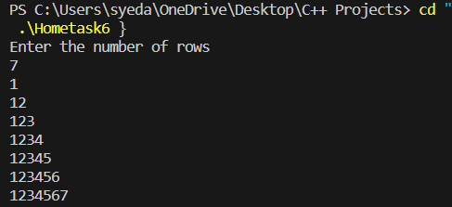

**Code 3:**

#include <iostream>

using namespace std;

//Task 3

int main()

{

    int row=4;

    int num=1;

    int j=1;

    //First for loop is for the number of rows(num is initialised to 1 so that row always starts with 1)

    for ( int i = 1; i <= row; i++)

    {

        //Second for loop controls the amount of numbers and value of number to be printed on output screen

        for(int j=1; j <= num; j++)

        {

            cout<<num;

        }

        if (num==1)

        {

            num*=2;

        }

        else

        {

            num+=2;

        }

        cout<<endl;

    }

    return 0;

}

**Output 3:**

